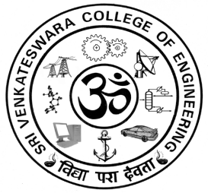
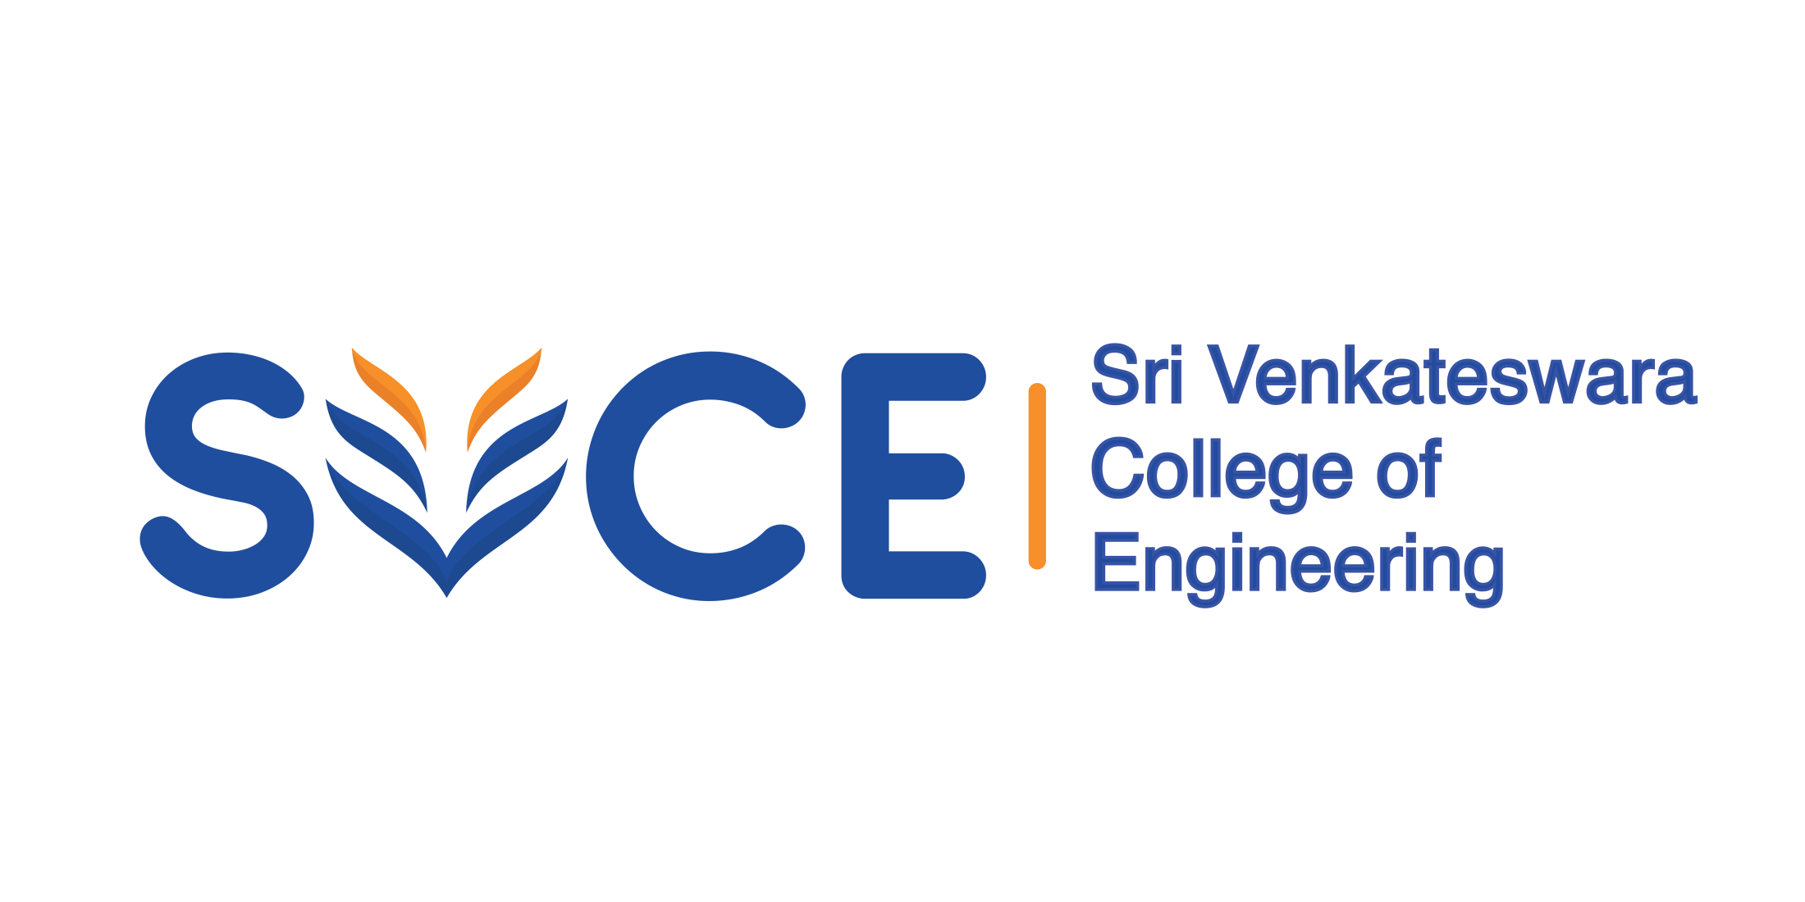

SVCE INNOVATES 2024

Students’ Research Day

Circular 22/2/2024

SVCE Students’ Research Day is a yearly event designed to highlight the depth of research and scholarly activities that undergraduate and Post-graduate students have accomplished during their studies. It provides an opportunity for staff and students to meet and share their experiences, ongoing research work and ideas, to promote discussions and strengthen collaboration across the departments.

The event comprises oral presentations of their research concepts, poster presentations, and research awards.

Competition details

Abstract should be submitted in a maximum of 500 words and the format for the abstract can be downloaded from the website.
-------------------------------------------------------------------------------------------------------
Important Dates

Submission of an abstract of the innovative ideas : 5/4/2024 (Friday)

Final event will be held on SVCE students Research Day : 16/4/2024(Tuesday)
--------------------------------------------------------------------------------------------------------
Team can consist of 2-3 students. Interdisciplinary teams are encouraged. Each team must have a faculty mentor. All participants will get participation certificates. Best innovative ideas in each branch will get prize money and certificate of Appreciation

Certificates would also be given to the faculty mentors of the winning teams.
A panel of judges from the industry and academia will evaluate the innovative ideas.

All the participants will have to demonstrate the ideas using poster/Models/software protypes.

Dr R Muthucumaraswamy, Dean (Research) Principal

Annexure- II

EVENT: SVCE INNOVATES 2024

Students are requested to submit their abstract to the respective department research coordinator through e-mail and also submit the hard copy of the abstract and registration form

S.No | Department | Research Coordinator(s) | e-mail Id
1. | AUT | Dr V Ganesh | vinaganesh@svce.ac.in
2. | BIO | Dr G Karthigadevi | karthigadevig@svce.ac.in
3. | CIV | Ms Ruby Freyz | rubyfreya@svce.ac.in
4. | CHE | Dr R Palani | rpalani@svce.ac.in
5. | CSE/AI&DS | Dr N Rajganesh  Ms E Kiruthiga | rajganesh@svce.ac.in  kiruthigae@svce.ac.in
6. | ECE | Dr R Gayathri  Ms S M Mehzabeen | rgayathri@svce.ac.in  mehzabeen@svce.ac.in
7. | EEE | Dr T Annamalai | annamalai@svce.ac.in
8. | INT | Dr C Yaashuwanth  Mr K Suresh | yaashuwanth@svce.ac.in  ksuresh@svce.ac.in
9. | MEC/MAE | Dr M Gajendran | mgaja@svce.ac.in
10. | MAR | Mr V Gurusamy | vguru@svce.ac.in

Dr R Muthucumaraswamy, Dean (Research) Principal

SVCE INNOVATES 2024

STUDENTS’ RESEARCH DAY

Registration form

Title of the Innovative idea/Project:

Details of the team

Team Member | Name | Branch  & Year | Mail Id | Mobile number
1
2
3
Faculty (Mentor)

Broad areas under which this research work can be categorized:

1.

2.

3.

SVCE INNOVATES 2024

Title of the innovative idea/project:

Team ID(to be assigned by department coordinator) :

ABSTRACT

